Your sales rep should have Metrics in place for certain number of DAILY:
- Cold Call Visits
- Warm Sales Visits
- Sales Presentation Appointments
- Building Walk-throughs (after a sale)*
- Implementation Meetings (after sale)*
- Handwritten and mailed Thank You’s to those that signed or gave you their time
- Visits to existing clients to maintain the relationship (after first month)
- One day a week can be set aside for calling on Agents, Plumbers, and other

SUGGESTED DAILY METRICS (FOR MOST MARKETS) - minimums
10 | 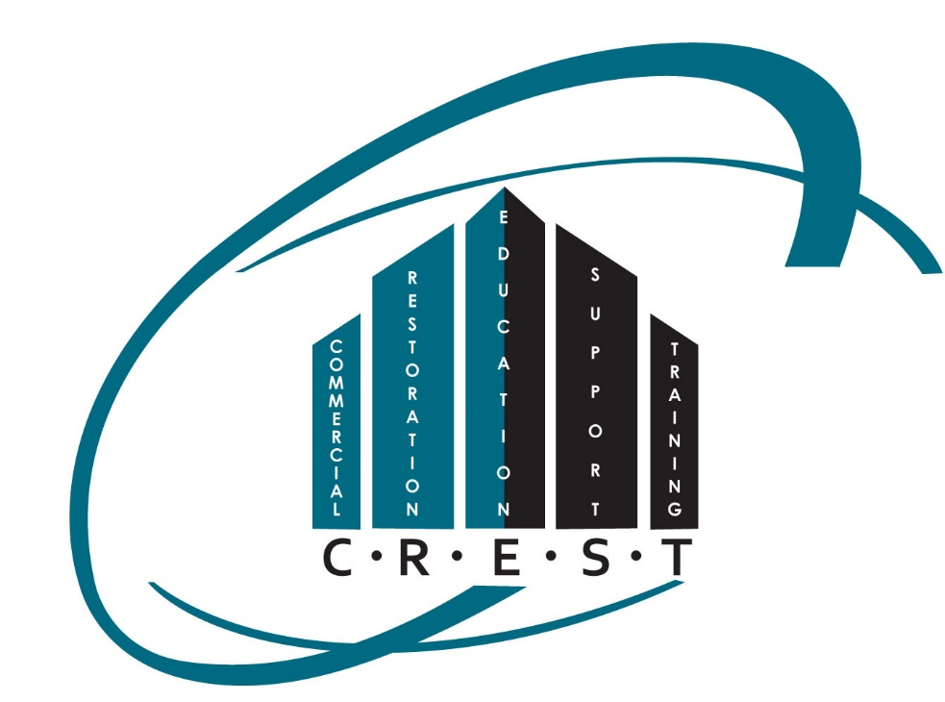  Cold Call Visits *
5 | Warm Sales Visits
1 | Appointment w/ Decision maker
1 | Building Walk-Through (after the Agreement is signed)
1 | Implementation Meeting**
5 | Handwritten Thank You's (Mailed)
10 | Resource Visits (after the sale)
* these may go down as the Sales Numbers go up (never less than 5 CCV in a day)
** Implementation meetings won’t happen every day (only as the sale and walk-through are completed)

A Cold Call Visit (CCV) means NEVER VISITED THE BUSINESS PREVIOUSLY.
A Warm Sales Visit (WSV means contacting someone in person that you have an “arms-length” relationship with – such as a Connection on LinkedIn or other Social Media accounts. OR: someone in the commercial world that you have been introduced to!
A Building Walk-Through (BWT) or Implementation (IMM) meeting will happen as part of the Sales process once the presentation has been made, and the customer signs an Agreement.
A Resource Visit (RSV) is the maintaining of the relationship once the sale is made. This means EVERY client is visited every month. Most “visits” will be a few minutes and will be simply dropping off a Maven Article that is pertinent to the CUSTOMER’s business or industry. (It’s NOT about you!)

