Interview Questions For Agents

Do you write both Personal Lines and Commercial policies?
__________________________________________________________
Do you have “specialty” types of products?
__________________________________________________________
How do you compete against the “internet” insurance sales?
__________________________________________________________
When your policyholder has a property claim, what do you do?
__________________________________________________________
What’s the biggest challenge selling insurance?
__________________________________________________________
If they have a high deductible, do you encourage them to have a
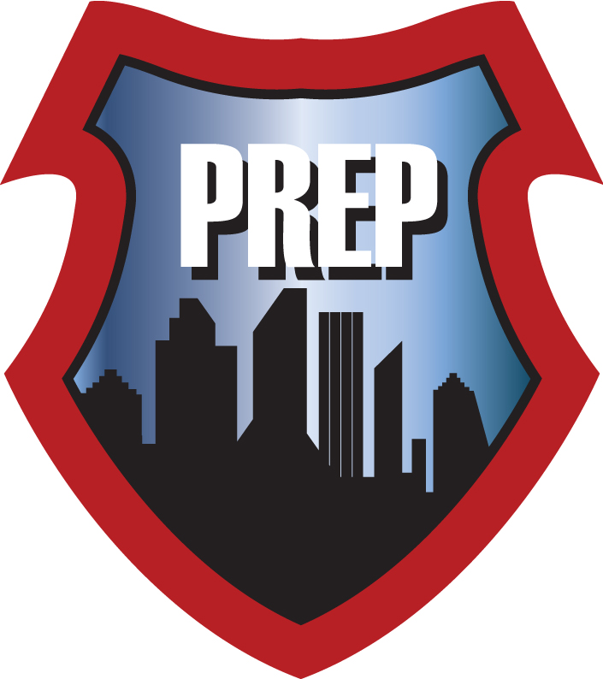
contractor inspect the loss before filing a claim?
__________________________________________________________
What has changed for you in the past 5 years in insurance sales?
__________________________________________________________
When you need to engage a contractor, what do you look for?
__________________________________________________________
What headaches have you had with previous contractors?
__________________________________________________________
Our goal is always… to make the Agent and the Carrier look good. What’s the best way we can do that?
__________________________________________________________
__________________________________________________________
Copyright – The CREST Network, LLC 2018-2019

