CRM Database Maintenance
__________________________________________________________________
__________________________________________________________________

Direct Mail
__________________________________________________________________
__________________________________________________________________

SMS - Text Message Marketing
__________________________________________________________________
__________________________________________________________________

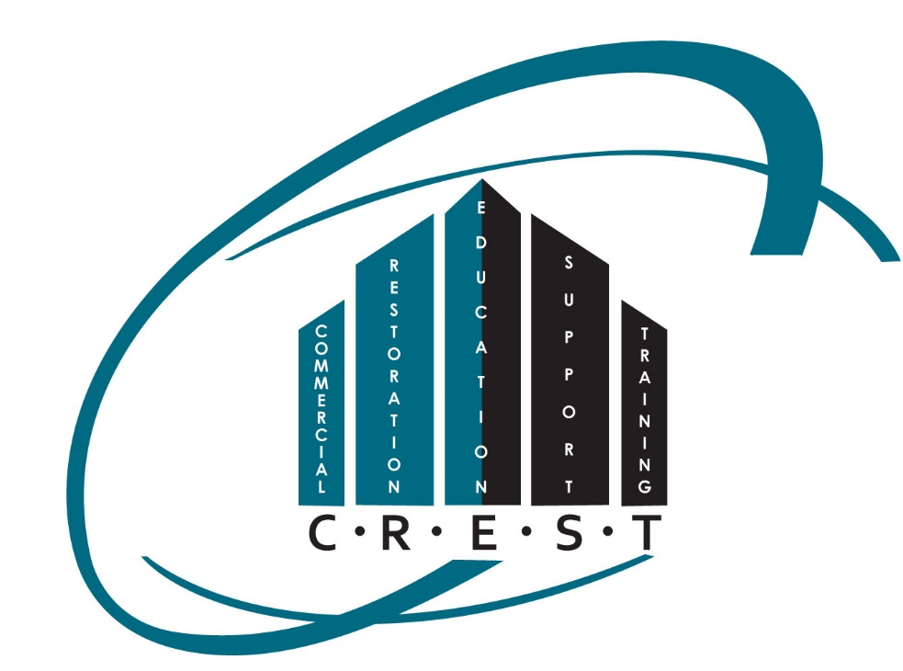
Survey (QC) system
__________________________________________________________________
__________________________________________________________________

Active Referral System
__________________________________________________________________
__________________________________________________________________

Testimonials Collection and Presentation
__________________________________________________________________
__________________________________________________________________

Cold Call Visits
__________________________________________________________________
__________________________________________________________________

Warm Lead Visits
__________________________________________________________________
__________________________________________________________________

Client Follow-ups
__________________________________________________________________
__________________________________________________________________

Resource Material Creation
__________________________________________________________________
__________________________________________________________________

Resource Material Distribution
__________________________________________________________________
__________________________________________________________________

Blog Articles Weekly
__________________________________________________________________
__________________________________________________________________

Social Media Daily Posting / Activity
__________________________________________________________________
__________________________________________________________________

CTA Call-to-action Free Downloads
__________________________________________________________________
__________________________________________________________________

CTA Call-to-action Follow-up
__________________________________________________________________
__________________________________________________________________

Automatic Website Responders
__________________________________________________________________
__________________________________________________________________

Differentiation (How You Are Different)
__________________________________________________________________
__________________________________________________________________

Business Branding
__________________________________________________________________
__________________________________________________________________

Personal Branding
__________________________________________________________________
__________________________________________________________________

Something You Want To Add
__________________________________________________________________
__________________________________________________________________
__________________________________________________________________

Note: As an owner or manager, this process should be of interest to you. If you’d like to schedule a specific call to discuss this in detail, please call Dick Wagner: 419-202-6745

